|  |  |
| --- | --- |
| **CONSERVATORY of MUSIC and DRAMA**  ASSIGNMENT COVERSHEET |  |

Please Type or Print Clearly

|  |  |
| --- | --- |
| Name | Liang-Hao Kwan (Leon) |
| Student Number | D16123199 |
| Course/Year | BMus/ Year 4 |
| Module/Unit | Studies in Music History & Perf Practice 2/ English Musical Renaissance |
| Lecturer | Dr Maria McHale |
| Essay Title | The Progressivist Edward Elgar and His Oratorio, The Dream of Gerontius |
| Word Count*  Number of Pages | 1576 Words  9 Pages |
| Deadline for Submission | 20 April 2020 |
| Date of Submission | 19 April 2020 |

If the assignment is being submitted after the due date, has an extension been

granted? Yes ☐ No ☐ N/A ☐

If an extension has been granted, please attach the completed/approved Extension Request Form.

**Declaration**

The material submitted is my own work and all information gleaned from other sources is appropriately referenced.

**Signed** _______Liang Hao Kwan__________ **Date** ____19 April 2020___

* Word count is inclusive of footnotes but exclusive of the bibliography.

**The Progressivist Edward Elgar and His Oratorio, *The Dream of Gerontius***

In nineteenth-century, English composers had been using materials from the Bible to write oratorios, and under the musical style of Handel and Mendelssohn.[1] Schmitz described Britain as ‘Das Land ohne Musik’ [The Land without Music], and he also wrote a book discussing why the English were considered the only cultured nation without its own music. However, Elgar was different from other English composers. After the German premiere of *Gerontius*, Strauss hailed Elgar as ‘the first English progressivist’. This essay will discuss what made Elgar a progressivist with his *Gerontius* and how.

Traditionally, Oratorios are a musical form that used a setting of sacred story or text and scored for a choir and a small group of instruments, and they are performed for events in church and music festivals in Britain.[2] According to McGuire, “laudas” and “histories” were the two main types of English oratorio.[3] Handel’s and Mendelssohn’s oratorios, such as *Messiah* and *Elijah*, are representing “laudas”, which applied biblical or biblical-sounding texts in a series of religious prayer in the setting and story.[4] On the other hand, “history” oratorios were usually set for dramatic events, such as battle, conversion or miracle.[5] Nevertheless, the difference is not significant and both types contained thoughtful and moral text.[6] Furthermore, English oratorios in nineteenth-century are strongly identified with Protestant tradition whereas the setting of *Gerontius* is based on a Roman Catholic poem by John Henry Newman written in 1866. It relates the journey of a religious man’s soul to his judgement before God and settling into purgatory.[7] The committee of the Birmingham music festival, which was a Protestant festival tradition, did not against to the Newman’s poem.[8] Additionally, all the other oratorios by Elgar fell into the category of “history” oratorios.[9] Also, Elgar’s oratorios tend to focus on the psychological aspect of characters, instead of introducing a dramatic situation with a spiritual frame.[10]

The first performance of *Gerontius* in Birmingham music festival was nearly a failure, as the amateur choir underestimated the complexity of such innovative work and did not expect it from a semi-professional festival tradition especially.[11] For example, the famous Demons’ Chorus from *Gerontius* contained some difficult leaps, it was nearly impossible for choir to sing. Apart from that, there were other reasons why the first performance was a disaster. Firstly, the chorusmaster Swinnerton Heap had died suddenly during the preparation.[12] Secondly, the conductor Richter had a heavy workload with extra rehearsals and preparation with the scores and parts.[13] Thirdly, Elgar insulted the choir during the rehearsal due to they were not taking it seriously, which caused bitterness.[14] Lastly, the soloists were not the perfect fit for the roles.[15] Hence, the first performance of *Gerontius* had disappointed Elgar deeply, and he wrote to his friend Jaeger: ‘I always said God was against art…I have allowed my heart to open once – it is now shut against every religious feeling’.[16] But, the performance of *Gerontius* in Düsseldorf in 1902 was highly successful and greatly impressed Strauss.[17]

The orchestration and the score of *Gerontius* are the fullest and most complicated in English music of the time.[18] It is a score for a full-size orchestra, three choirs, soloists and an organ. In the history, there are no English choral works had such prominent orchestra part and there are no English oratorios had soloists, chorus and orchestra been blended so stupendous.[19] The Wagnerian operatic prelude has shown many innovative ideas, for example, it is formed in formlessness and create the sonic representation of the musical world.[20] Also, It introduces many different representative themes can be found later in the work, such as Judgement, Fear, Prayer, Sleep, Miserere, Despair.[21]

Figure 1 Elgar, The Dream of Gerontius, the Theme of Judgement

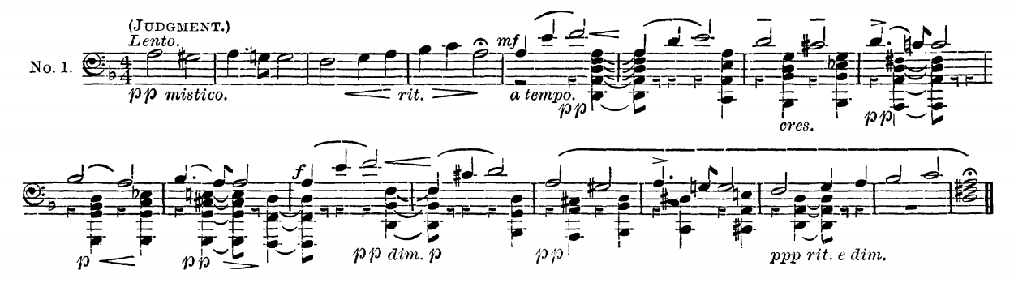

Figure 2 Elgar, The Dream of Gerontius, the Theme of Fear

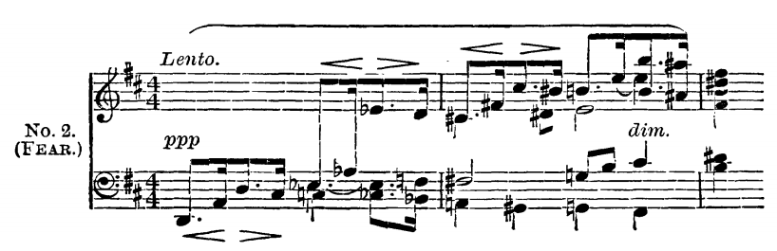

Figure 3 Elgar, The Dream of Gerontius, the Theme of Prayer

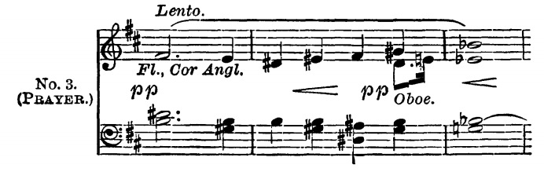

Figure 4 Elgar, The Dream of Gerontius, the Theme of Sleep

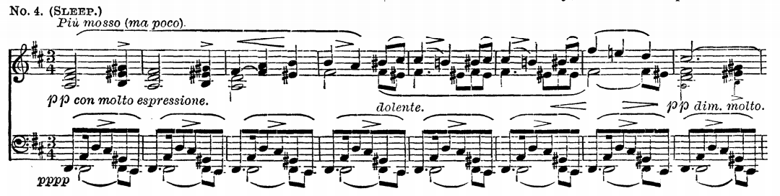

Figure 5 Elgar, The Dream of Gerontius, the Theme of Miserere

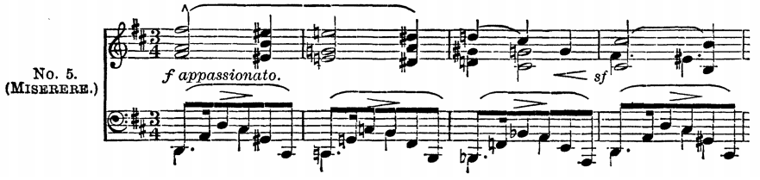

Figure 6 Elgar, The Dream of Gerontius, the Theme of Despair

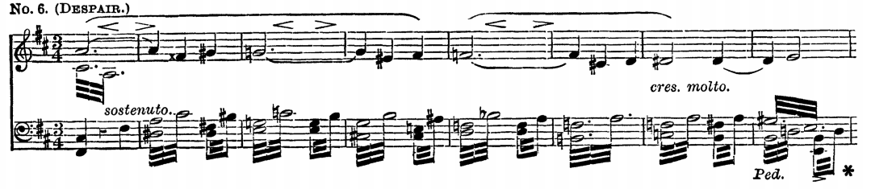

The listener can easily connect to the music once they understand the importance of various themes.[22] Elgar employed the use of associative tonality for labelling different themes.[23] For example, D for judgement, major is for good judgement whereas minor is for bad, C for Angels, and E-flat for prayers.[24] Besides that, the transition from ‘Kyrie’ to ‘Sanctus fortis’ in Part I (E-flat/B-flat), and when angels sing with the choir of Angelicals in Part II (C/E-flat), Elgar applied alternative key changing movement which Jaegar argued was to represent blocking away the human soul from the iron walls of the Judgement.[25] At the line ‘Tis this strange innermost abandonment’ in Part I, has an exceptional Elgarian orchestral effect painted the word ‘strange’.[26] This holy and enlightened sounding is created by strings divided into fifteen parts, sustain for one bar with *ppp* in dynamic, and proceeded by a long pause.[27]

Figure 7 Elgar, The Dream of Gerontius, Part I, ‘Tis this Strange innermost abandonment’

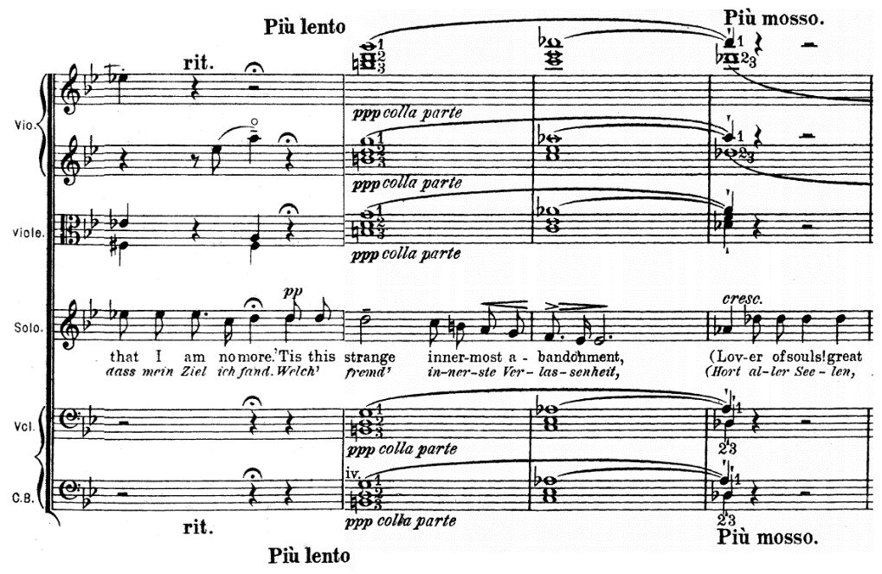

Moreover, the most notable section in *Gerontius* is the Demons’ chorus in part two. At the line ‘And realm of light’, Elgar painted the word ‘light’ with a big leap in the chorus and a *ffz* crash.[28]

Figure 8 Elgar, The Dream of Gerontius, Part II, ‘And realm of light’

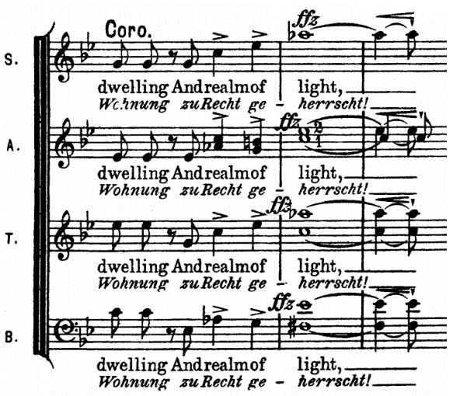

Then it followed by the exposition of a complicated double fugue section started at the line ‘Dispossessed’, which creates a dark demoniac sounding with dissonances.[29] In contrast, the choir of Angelicals is much sweeter and magnificent sounding. The voices in this section are divided into semi-chorus of two or four parts and chorus in four or eight parts.[30]

The argument of Elgar’s *Gerontius* has a strong influence from Wagner’s music, and *Gerontius* is a semi- or un-English work are often discussed. In 1882, the complete performances of *Der Ring des Nibelungen, Die Meistersinger,* and *Tristan und Isolde* were performed in Britain.[31] For twentieth-century composers, it was difficult to avoid the influence of Wagner.[32] Many Elgar scholars believed *Gerontius* remains the most Wagnerian of any of Elgar’s oratorios, with the Wagnerian elements: the use of the term “Prelude” for the opening; the use of chromatic harmonies; the use of representative themes to provide coherence; the use of leitmotifs; and a unified subject.[33] Aside from that, the elements of orchestration in *Gerontius* are influenced by Wagner.[34] The orchestration of *Gerontius* is large and complicated, and it takes more instruments to introduce and increase the use of representative themes.[35] However, the differences between Elgar and Wagner are still existed.[36] Adams argues that Elgar did not use the same type of themes and thematic transformation that Wagner used.[37] Also, Elgar abandoned the Wagnerian constant thematic and harmonic elision, and created discrete melodies articulated by cadences.[38] Further, Elgar remains the use of traditional forms, such as arias and choruses.[39] Nonetheless, it is fair to say Elgar’s most characteristic innovations were conflicted with Wagnerian influences.[40]

In conclusion, the progressivist Elgar and his greatest oratorio have become an important work in Britain, despite itis a Catholic-based story and its music that was strongly influenced by Wagner. Elgar’s progressive movement which cannot be ignored is combining the religious story setting and the complicated harmony and orchestration which contained many dissonances and colours. Also, his sensitivity to the psychological aspect of characters and transform it into music, for example the representative themes. Elgar’s music influenced further composers, such as Vaughan Williams, Bliss and Walton.[41]

Bibliography

Online Articles

1. Smither, Howard E.: ‘Oratorio’, *Grove Music Online* (Oxford University Press), accessed 6 March 2020, <https://www-oxfordmusiconline-com.tudublin.idm.oclc.org/grovemusic/view/10.1093/gmo/9781561592630.001.0001/omo-9781561592630-e-0000020397?rskey=N8R2Gr&result=1#omo-9781561592630-e-0000020397-div1-0000020397.8>
2. McVeagh, Diana: ‘Elgar, Sir Edward’, Grove Music Online (Oxford University Press), accessed 6 March 2020, <https://www-oxfordmusiconline-com.tudublin.idm.oclc.org/grovemusic/view/10.1093/gmo/9781561592630.001.0001/omo-9781561592630-e-0000008709?rskey=JLFkqZ#omo-9781561592630-e-0000008709-div1-0000008709.7>
3. Millington, Barry, Deathridge, John, Dahlhaus, Carl, and Bailey, Robert: ‘Wagner, (Wilhelm) Richard’ Grove Music Online (Oxford University Press), accessed 8 March 2020, <https://www-oxfordmusiconline-com.tudublin.idm.oclc.org/grovemusic/view/10.1093/gmo/9781561592630.001.0001/omo-9781561592630-e-6002278269>

Books

1. McGuire, Charles, E.: *The Oratorios of Edward Elgar* (Hampshire: Ashgate Pub Ltd, 2002)
2. McHale, Maria: ‘How could an English composer be … so utterly and entirely un-English? Elgar and the *Dream of Gerontius*’, *The Musicology Review: Issue 3*, ed. Lyons, Helen, Kehoe. Thomas (Dublin: UCD Press, 2007)

Kennedy, Michael: *The life of Elgar* (Cambridge: Cambridge University Press, 2011)

Jarger, August J.: *The Dream of Gerontius: Analytical and descriptive notes* (Suffolk: Novello Pub Ltd, 1974)

Harper-Scott, J.P.E.: *Edward Elgar, Modernist* (Cambridge: Cambridge University Press, 2006)

Adams, Byron: ‘Elgar’s Later Oratorios: Roman Catholicism, Decadence and the Wagnerian Dialectic of Shame and Grace’, *The Cambridge Companion to Elgar*, ed. Grimley, Daniel M., Rushton, Julian (Cambridge: Cambridge University Press, 2005)

Parrott, Ian: *The Master Musicians series: Elgar* (London: J. M. Dent & Sons Ltd, 1971)

1. McGuire, Charles, E.: *The Oratorios of Edward Elgar* (Hampshire: Ashgate Pub Ltd, 2002), 31.
2. Smither, Howard E.: ‘Oratorio’, *Grove Music Online* (Oxford University Press), accessed 6 March 2020, <https://www-oxfordmusiconline-com.tudublin.idm.oclc.org/grovemusic/view/10.1093/gmo/9781561592630.001.0001/omo-9781561592630-e-0000020397?rskey=N8R2Gr&result=1#omo-9781561592630-e-0000020397-div1-0000020397.8>
3. McGuire, Charles, E.: *The Oratorios of Edward Elgar*, 31.
4. *Ibid.*
5. *Ibid*, 32.
6. *Ibid.*
7. McVeagh, Diana: ‘Elgar, Sir Edward’, Grove Music Online (Oxford University Press), accessed 6 March 2020, <https://www-oxfordmusiconline-com.tudublin.idm.oclc.org/grovemusic/view/10.1093/gmo/9781561592630.001.0001/omo-9781561592630-e-0000008709?rskey=JLFkqZ#omo-9781561592630-e-0000008709-div1-0000008709.7>
8. McHale, Maria: ‘How could an English composer be … so utterly and entirely un-English? Elgar and the *Dream of Gerontius*’, *The Musicology Review: Issue 3*, ed. Lyons, Helen, Kehoe. Thomas (Dublin: UCD Press, 2007)
9. McGuire, Charles, E.: *The Oratorios of Edward Elgar*, 35.
10. *Ibid.*
11. Kennedy, Michael: *The Life of Elgar* (Cambridge: Cambridge University Press, 2011), 78-79.
12. McVeagh, Diana: ‘Elgar, Sir Edward’, Grove Music Online (Oxford University Press)
13. *Ibid.*
14. *Ibid.*
15. *Ibid.*
16. Kennedy, Michael: *The life of Elgar*, 79.
17. *Ibid*, 85
18. Jaegar, August J.: *The Dream of Gerontius: Analytical and descriptive notes* (Suffolk: Novello Pub Ltd, 1974), 3.
19. Kennedy, Michael: *The life of Elgar*, 80.
20. McGuire, Charles, E.: *The Oratorios of Edward Elgar*, 142.
21. Jarger, August J.: *The Dream of Gerontius: Analytical and descriptive notes*, 3-8.
22. Jaegar, August J.: *The Dream of Gerontius: Analytical and descriptive notes*, 3.
23. Harper-Scott, J.P.E.: *Edward Elgar, Modernist* (Cambridge: Cambridge University Press, 2006), 14.
24. *Ibid*, 14.
25. *Ibid.*
26. Jaegar, August J.: *The Dream of Gerontius: Analytical and descriptive notes*, 8.
27. *Ibid*.
28. Jarger, August J.: *The Dream of Gerontius: Analytical and descriptive notes*, 21-22.
29. *Ibid,* 22.
30. Jarger, August J.: *The Dream of Gerontius: Analytical and descriptive notes,* 26.
31. Millington, Barry, Deathridge, John, Dahlhaus, Carl, and Bailey, Robert: ‘Wagner, (Wilhelm) Richard’ Grove Music Online (Oxford University Press), accessed 8 March 2020, <https://www-oxfordmusiconline-com.tudublin.idm.oclc.org/grovemusic/view/10.1093/gmo/9781561592630.001.0001/omo-9781561592630-e-6002278269>
32. *Ibid.*
33. McGuire, Charles, E.: *The Oratorios of Edward Elgar*, 139.
34. *Ibid.*
35. *Ibid*.
36. *Ibid*.
37. Adams, Byron: ‘Elgar’s Later Oratorios: Roman Catholicism, Decadence and the Wagnerian Dialectic of Shame and Grace’, *The Cambridge Companion to Elgar*, ed. Grimley, Daniel M., Rushton, Julian (Cambridge: Cambridge University Press, 2005), 87.
38. *Ibid.*
39. *Ibid.*
40. Parrott, Ian: *The Master Musicians series: Elgar* (London: J. M. Dent & Sons Ltd, 1971), 83.
41. Parrott, Ian: *The Master Musicians series: Elgar* (London: J. M. Dent & Sons Ltd, 1971), 96.